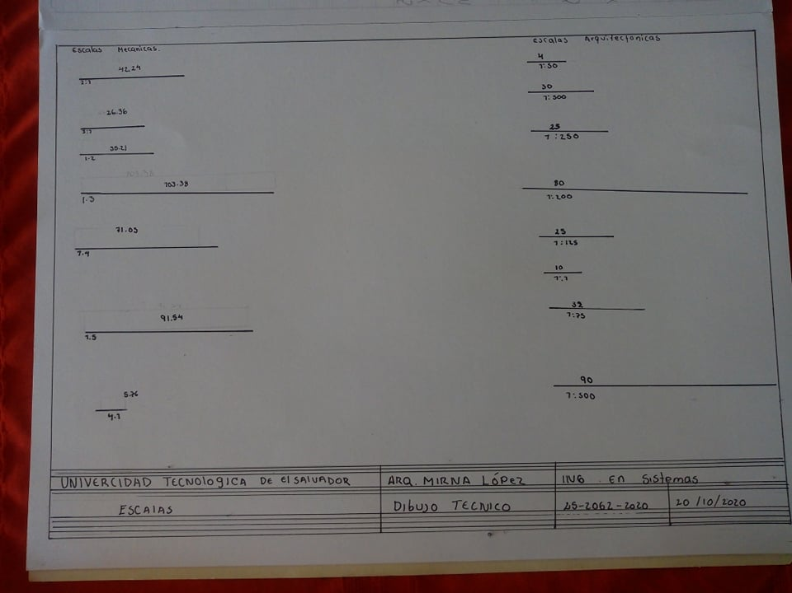

Krissia magali dueñas Molina 2520622020